Task1

2. output voltage: 1.01

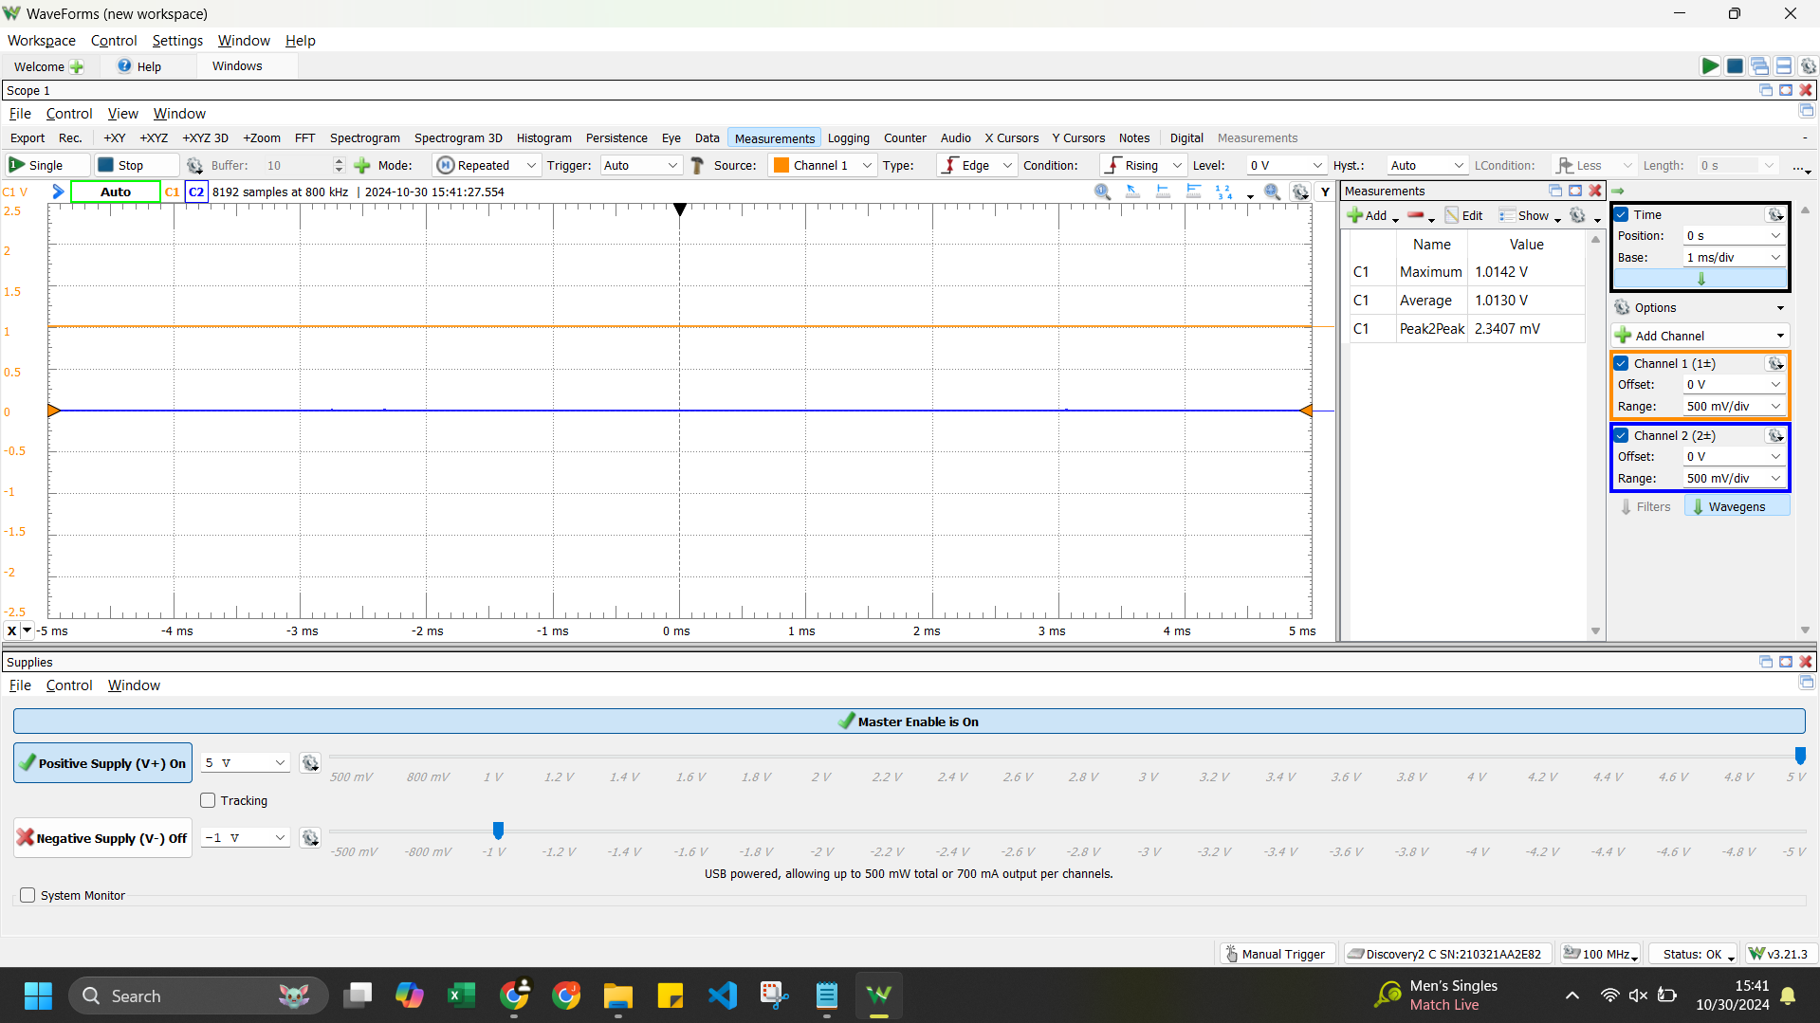

4. measure ambient temp

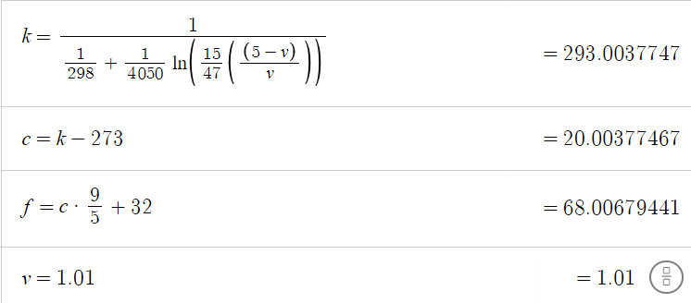

4. screenshot of data logger graph in waveforms

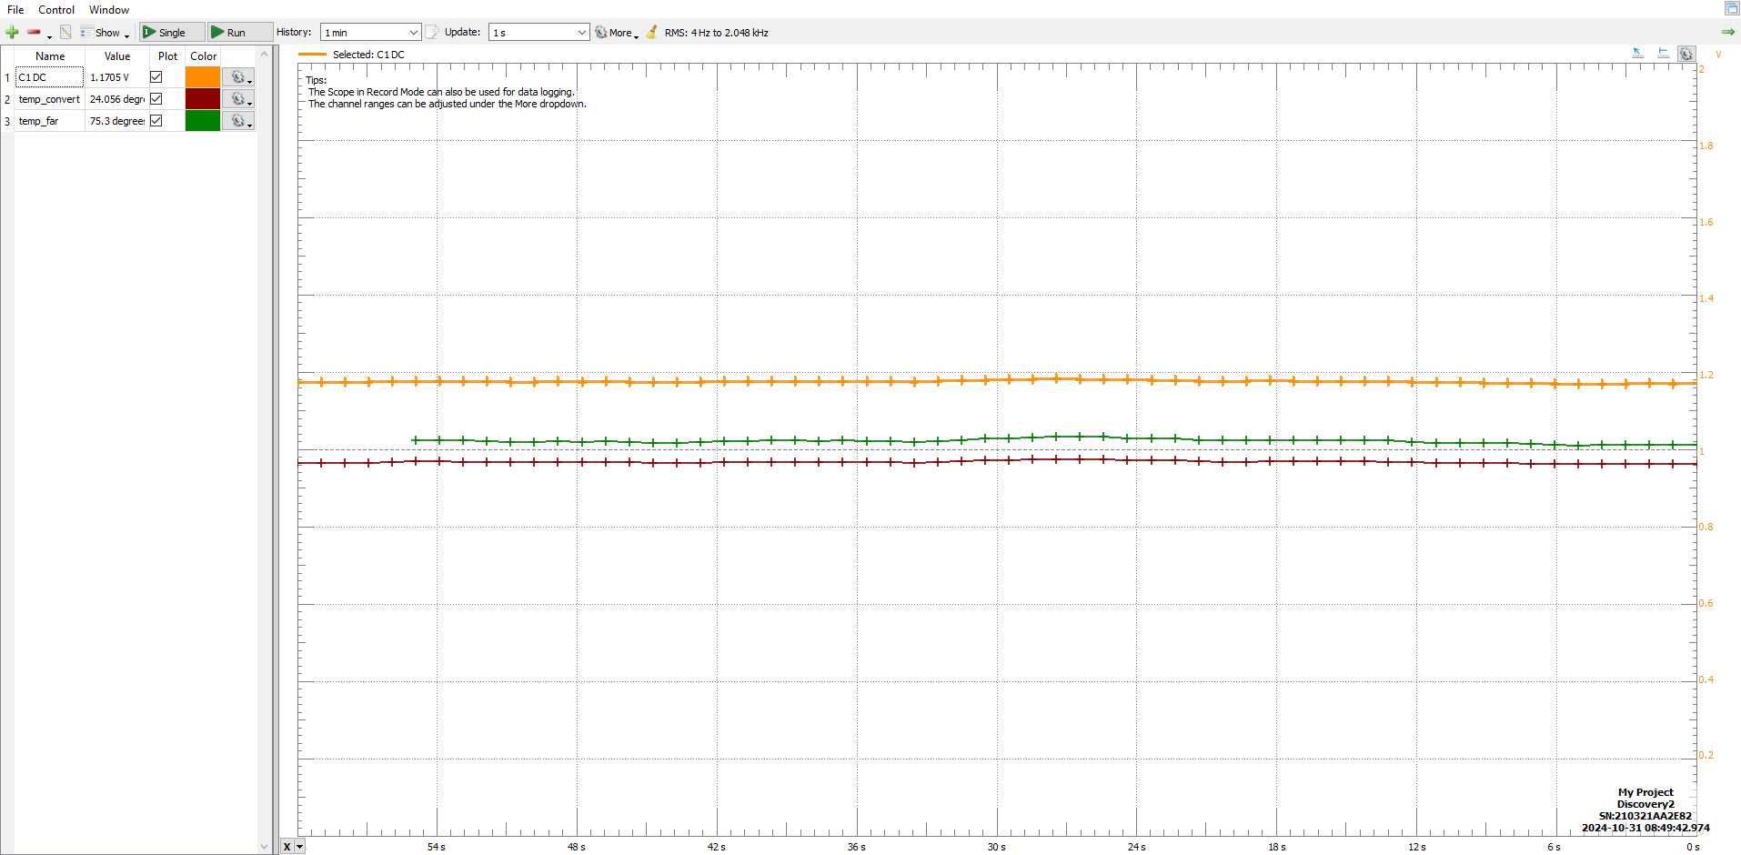

5. chilled thermistor new output voltage and temp

1 / ( (1/298) + (1/4050) * logn( (15/47) *( (5-v) / v ) )

6. pinched thermistor new output voltage and temp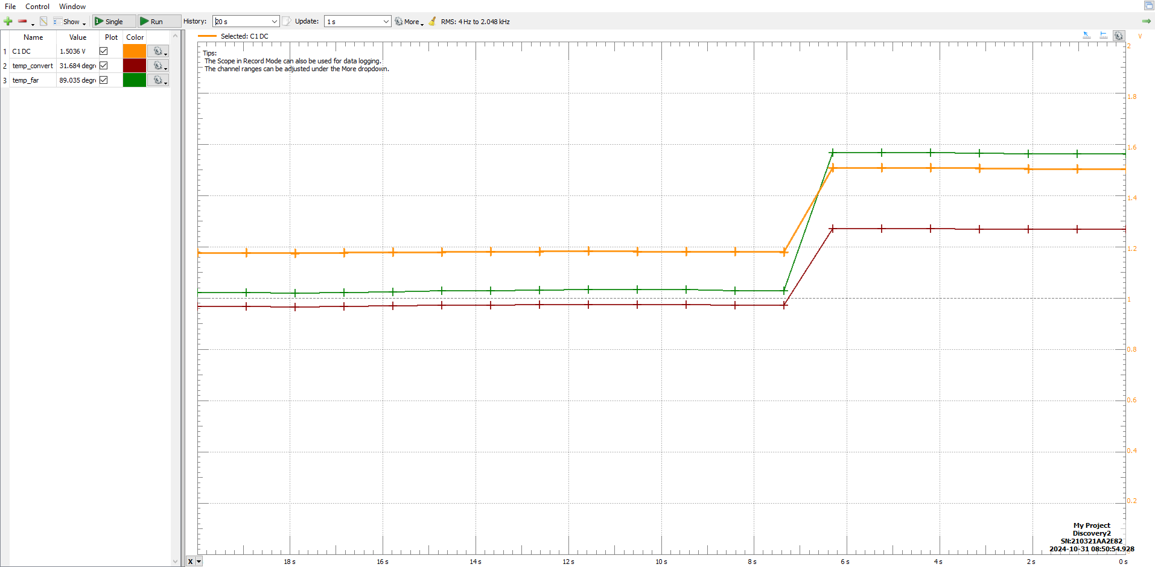

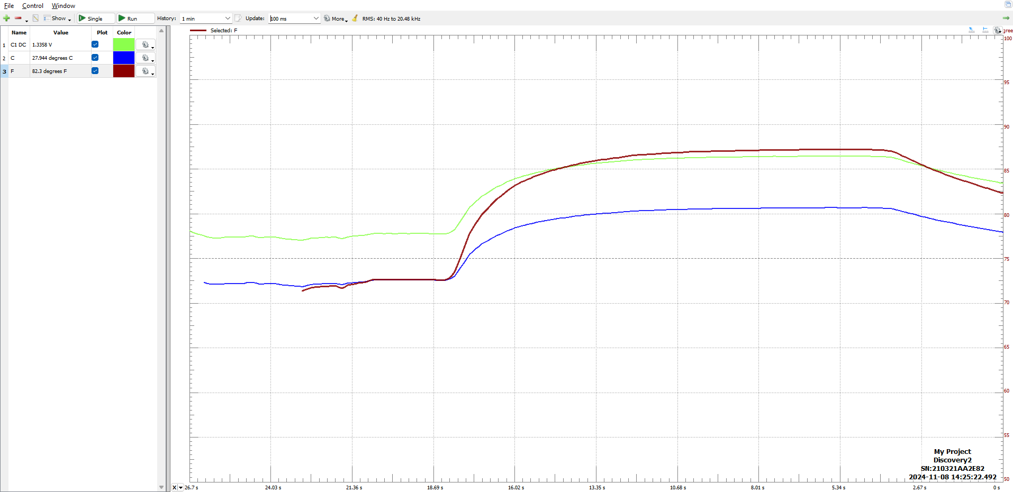

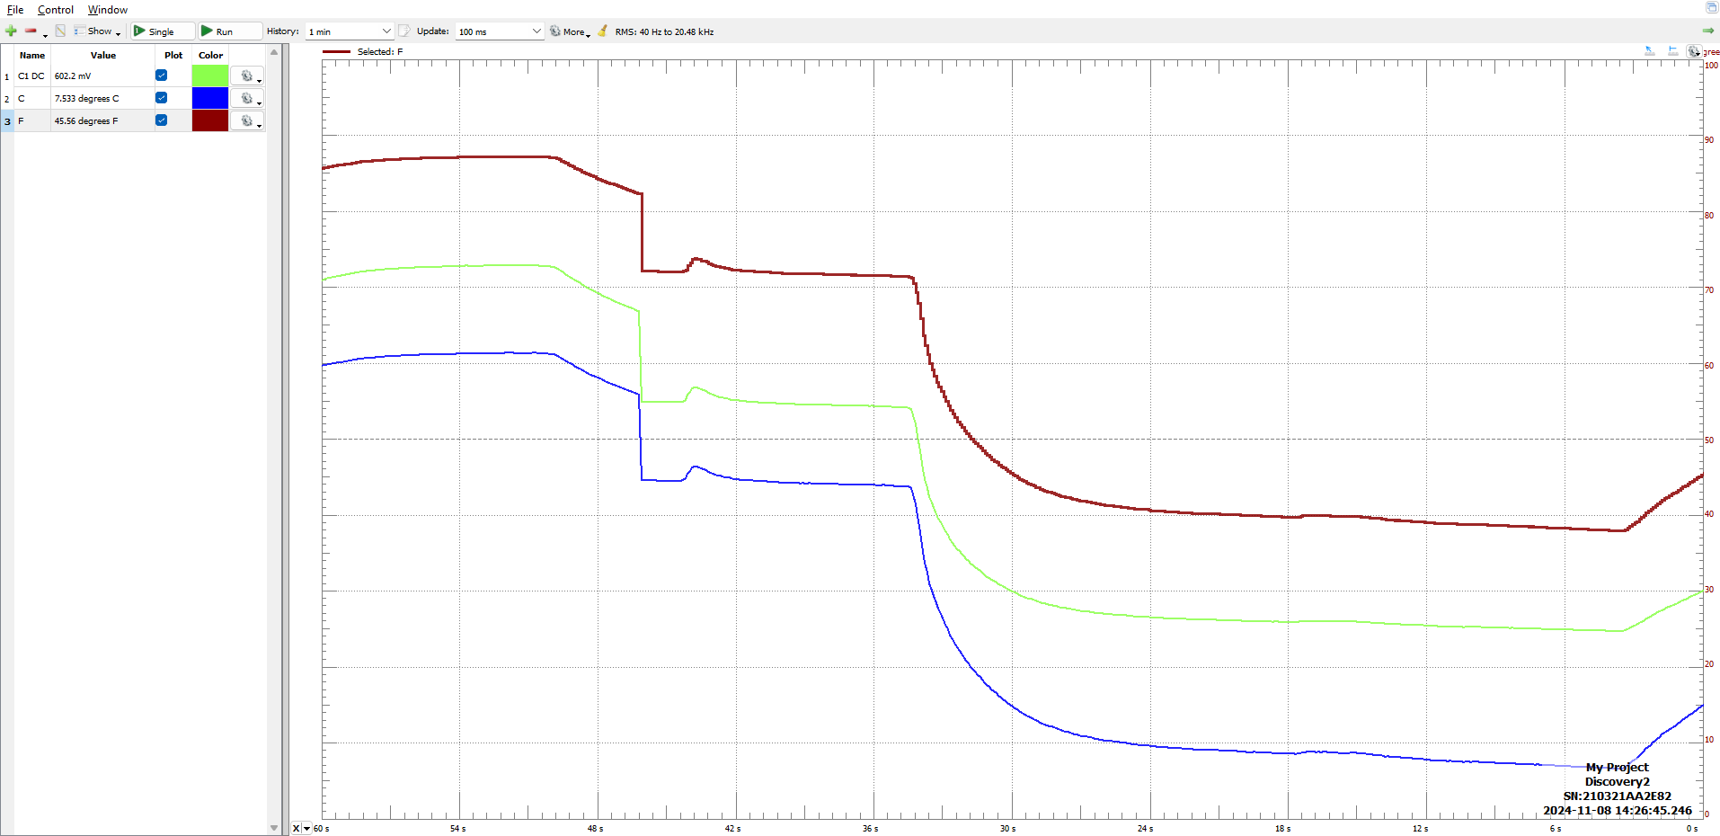

Cel

var base = 2.71828182845904;

var voltage = C1DC;

1/ ( (1/298) + (1/4050) * Math.log( (15/ 47) * ((5-voltage)/voltage) ,base)) - 273

Fah

var base = 2.71828182845904;

var voltage = C1DC;

var T = 1/ ( (1/298) + (1/4050) * Math.log( (15/ 47) * ((5-voltage)/voltage) ,base)) - 273

T * 9 / 5 +32

Task2

4. screenshot of vpwm and vtouch when sensor not attached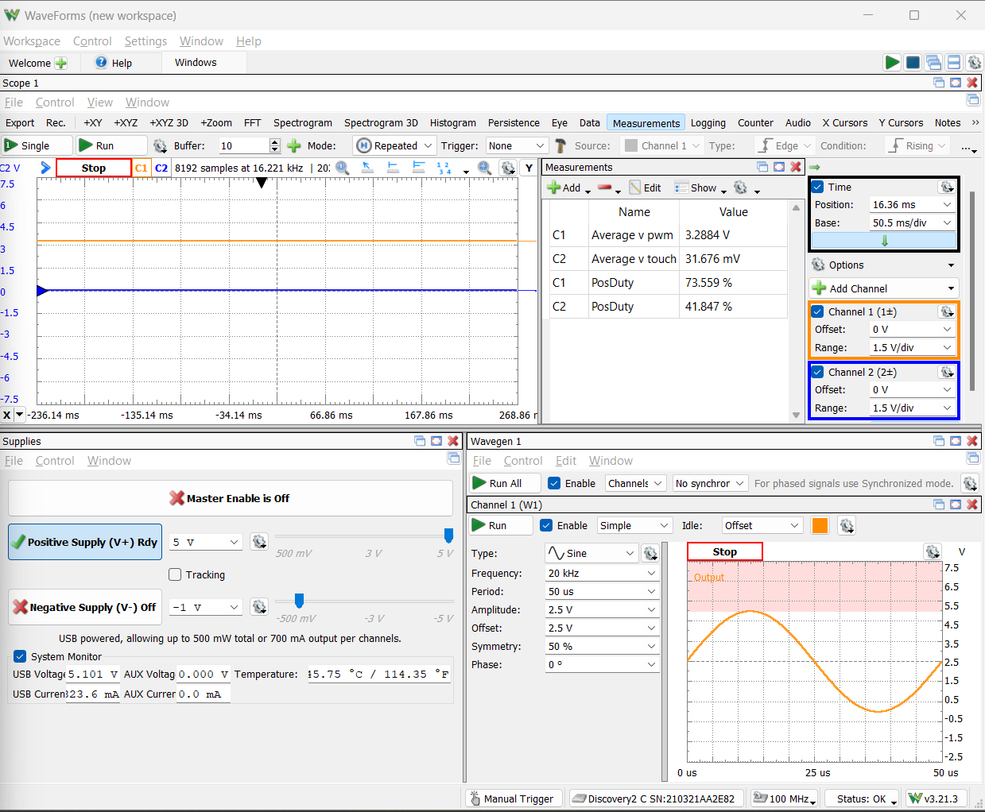

Vpwm = 3.2884V

Vtouch = 31.676mV

Attempt 2:

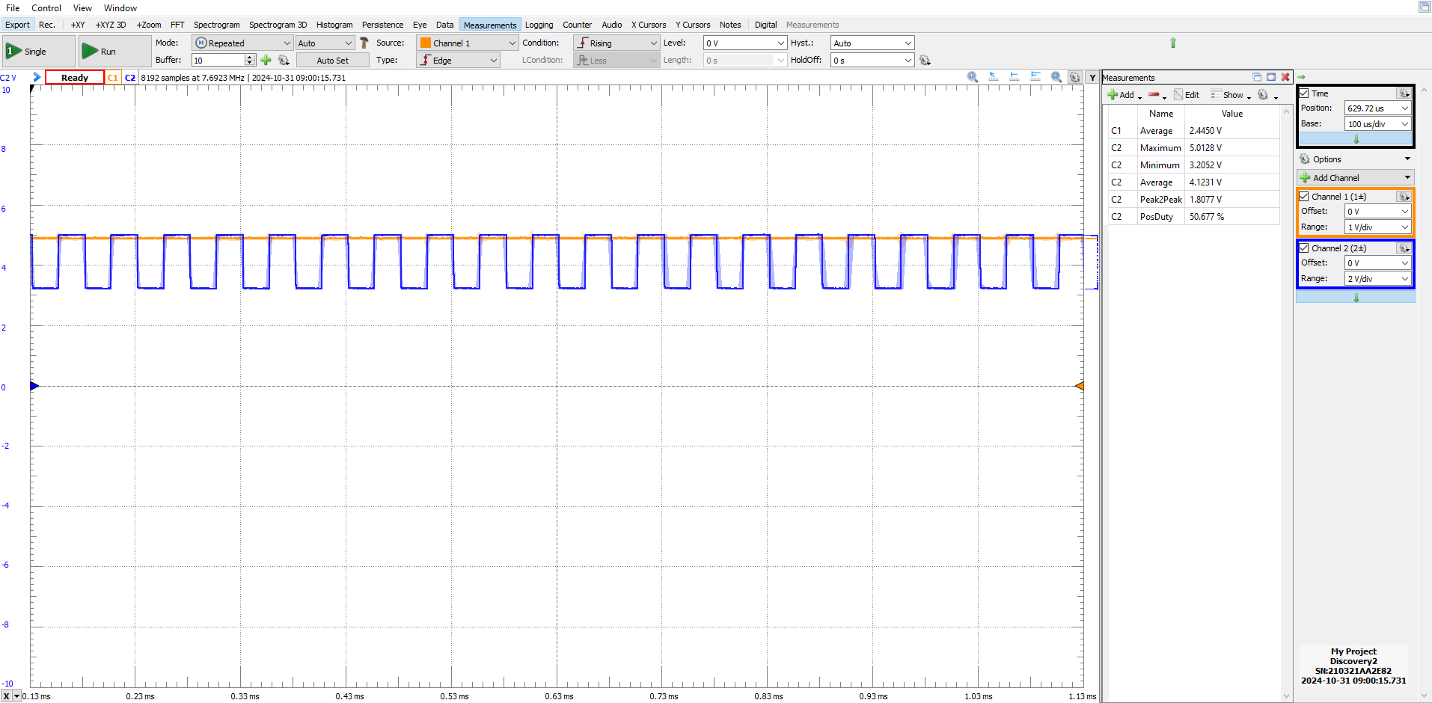(1 - vtouch, 2 - vpwm)

5. record duty cycle of output after sensor is attached

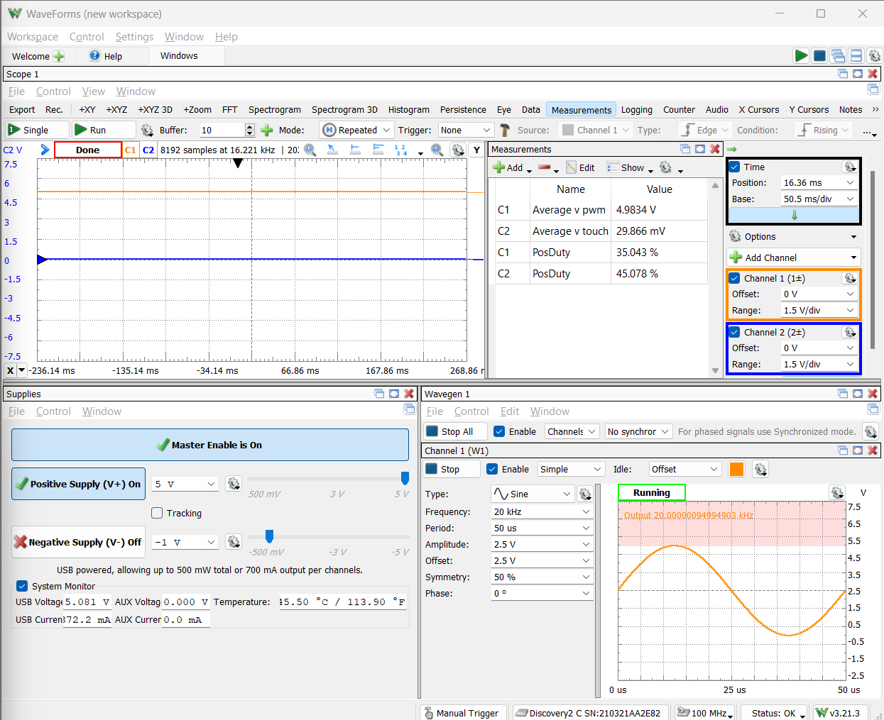

Attempt 2:

6. record duty cycle of output after touching insulation of touch sensor wires

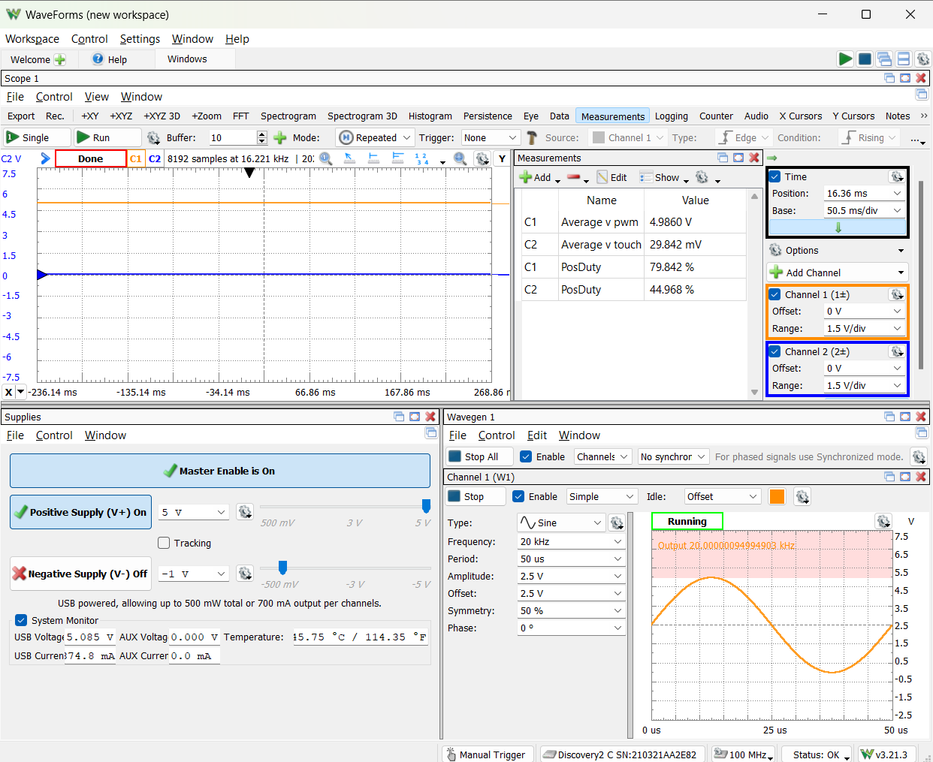

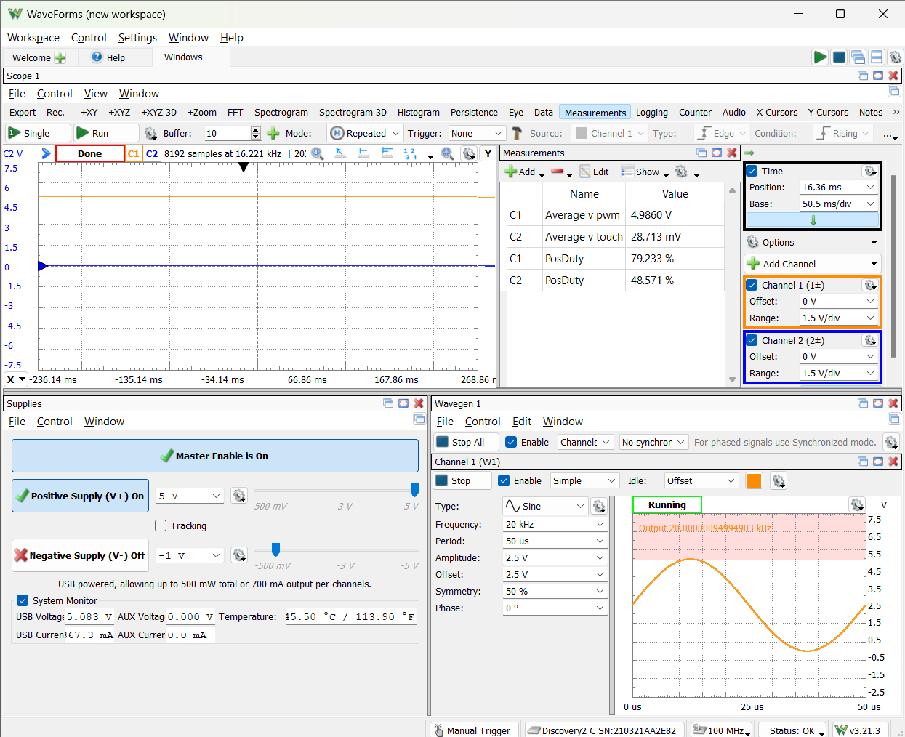

7. vary pressure

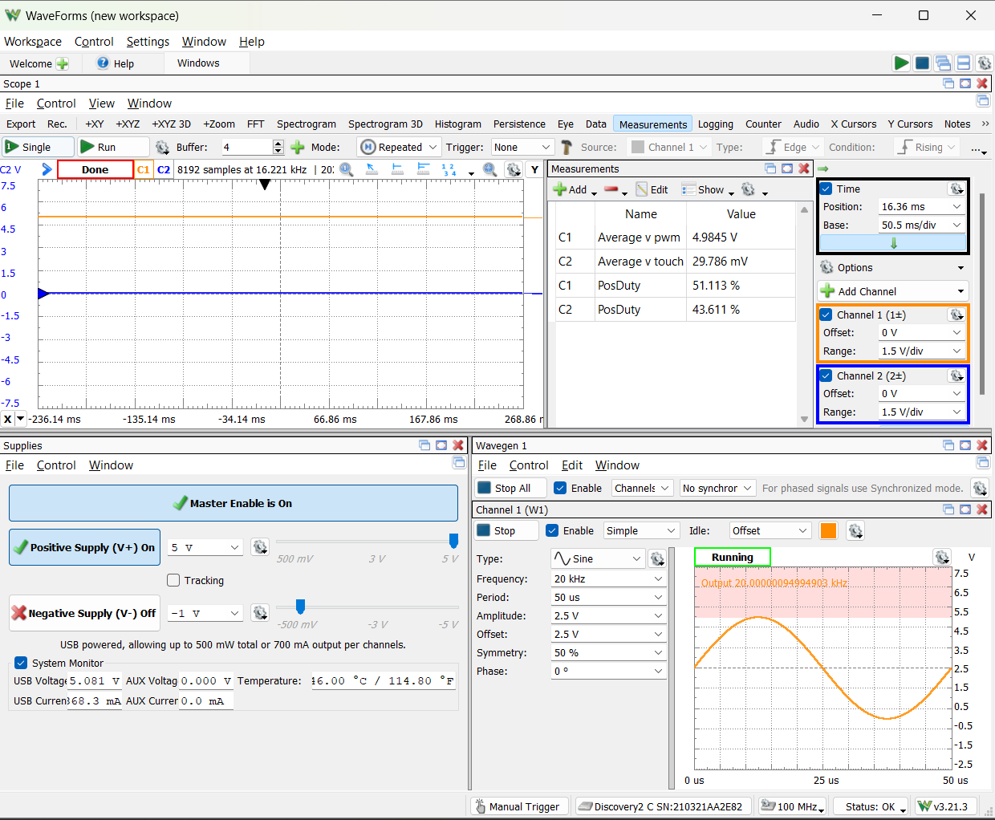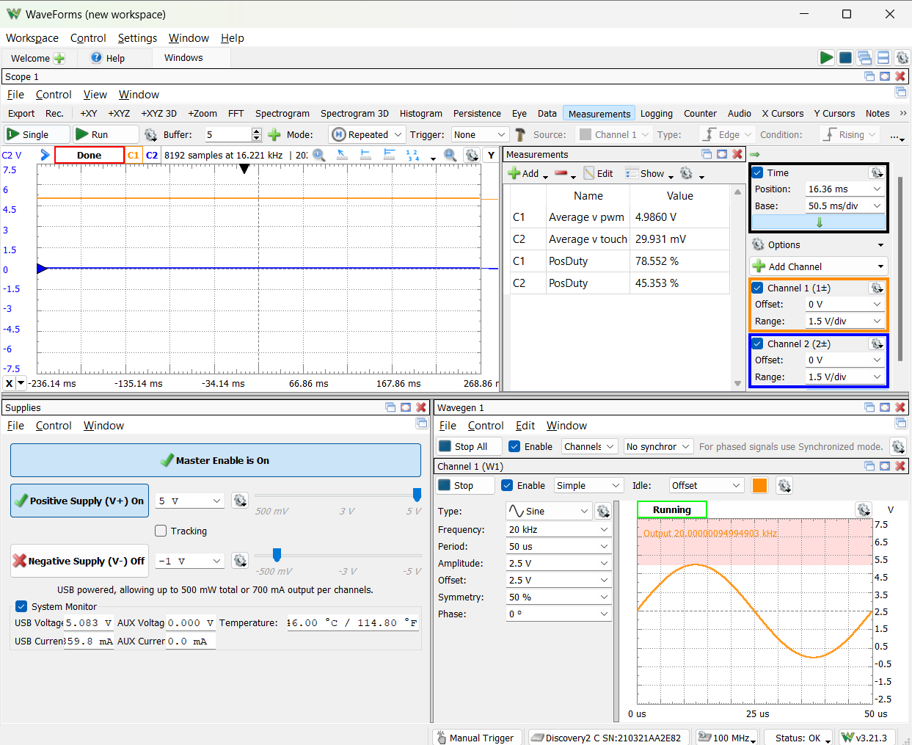

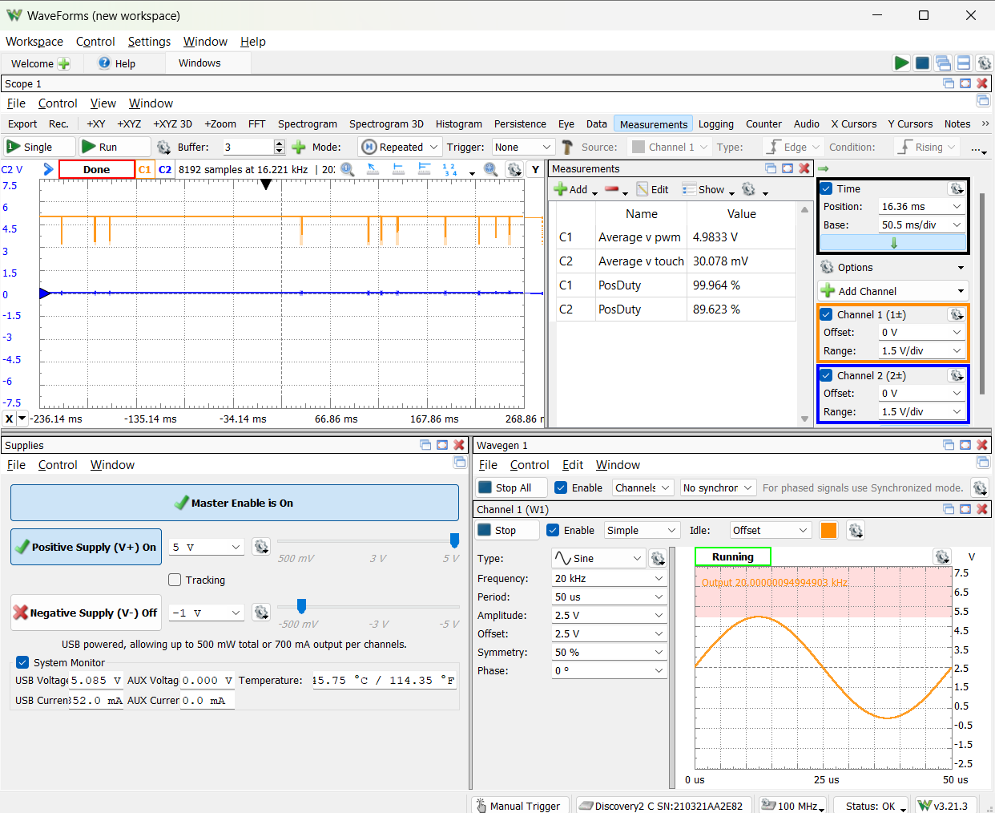

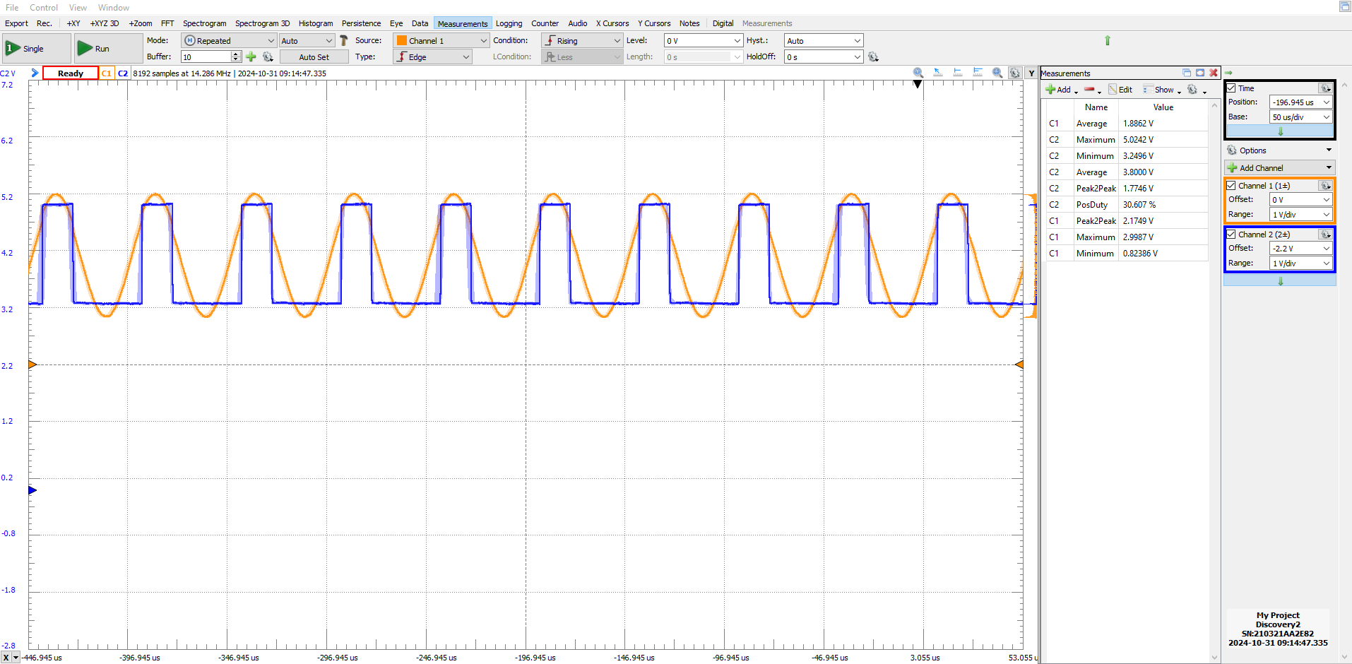



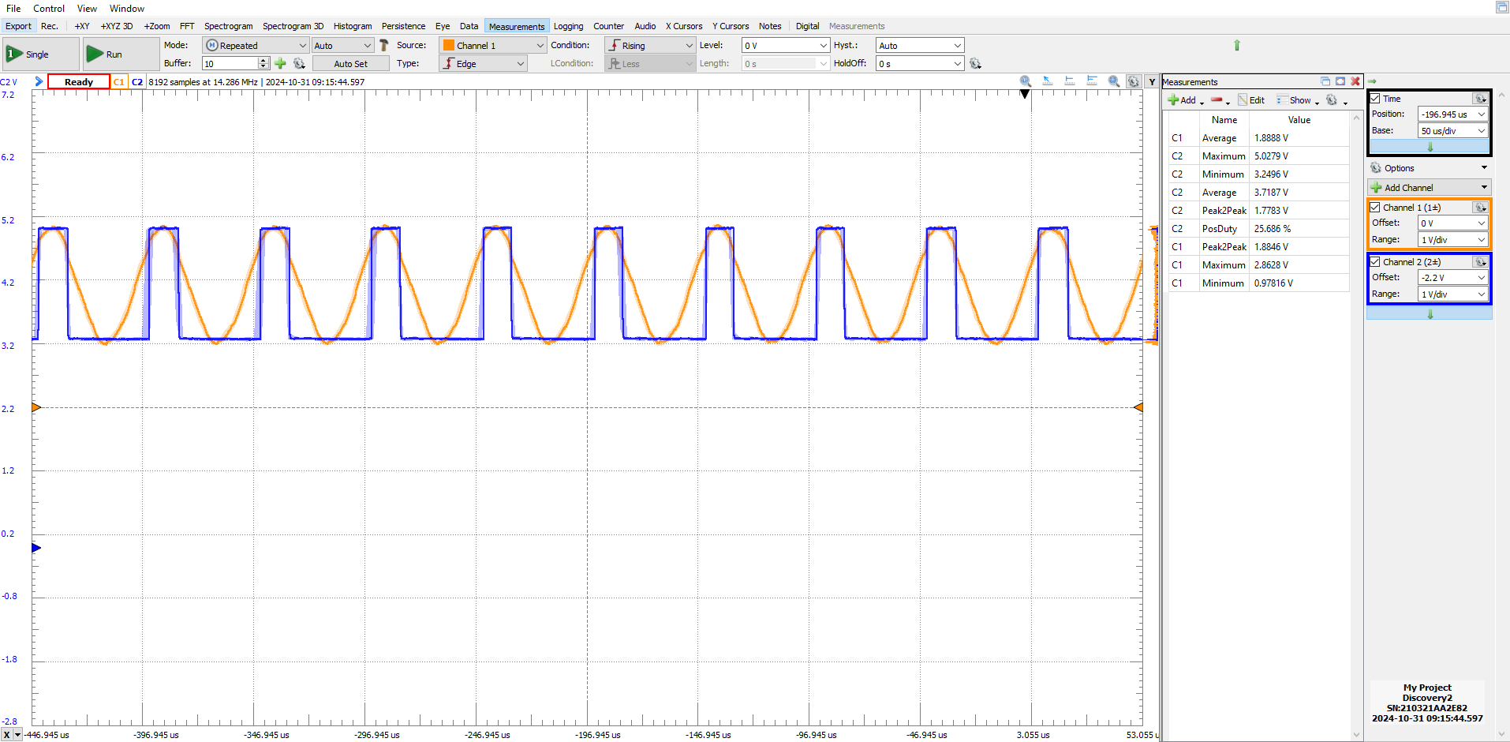

Task3

Just describe how you soldered

Task4 (extra credit)

2. measure vpt

Unblocked

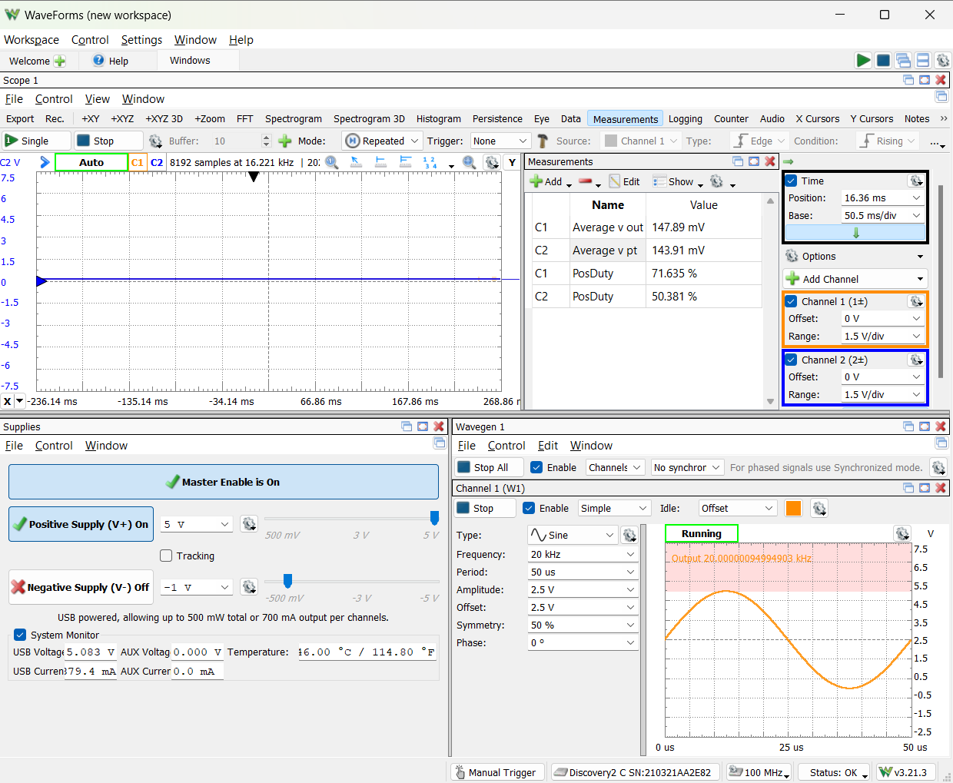

blocked

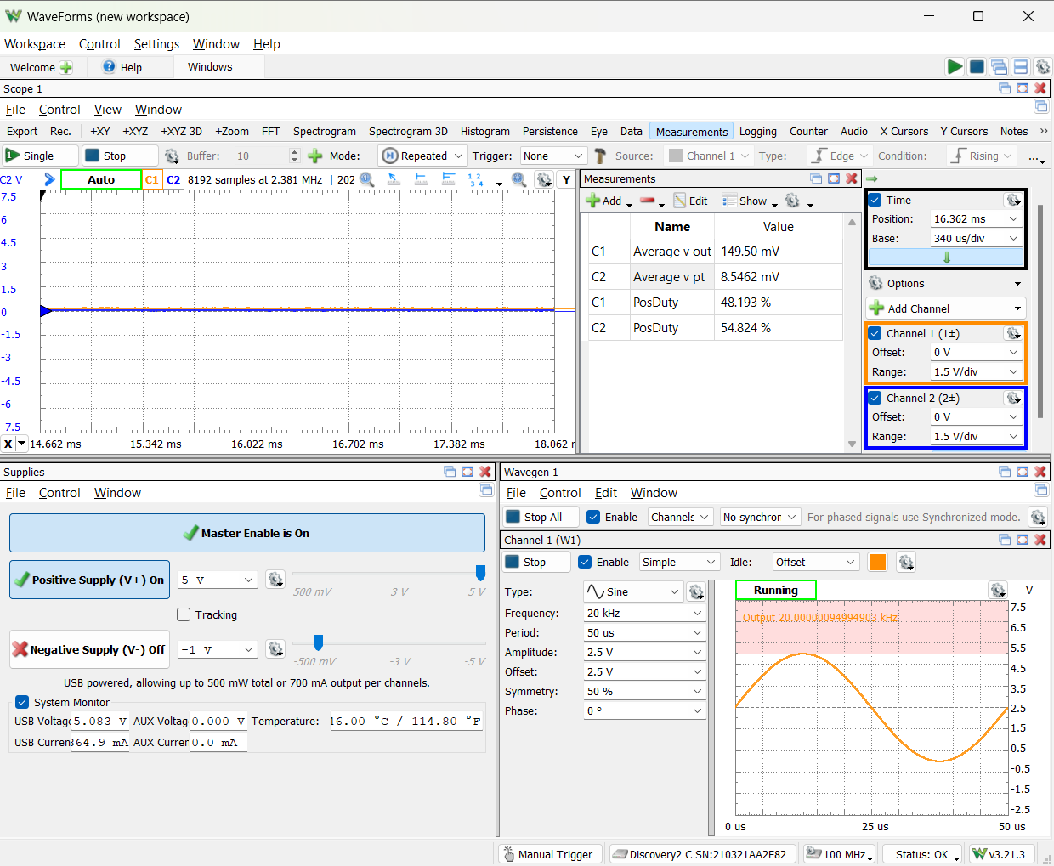

3. change light and describe relationship between vpt and the distance of the pbject to sensor

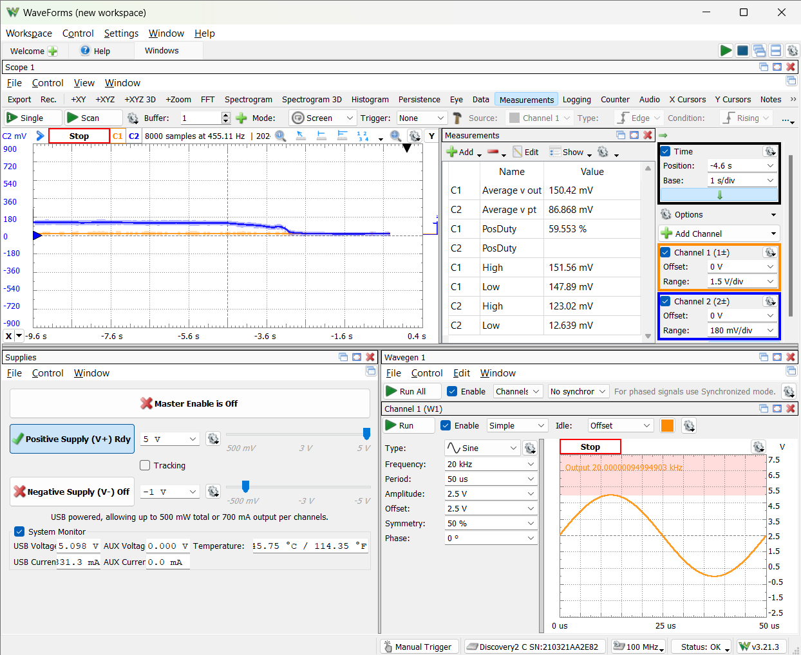Hand moves closer ----->

4. record voltage of vpt ~5cm away

6. record value vout when its >5cm and <5cm

|  |  |  |
| --- | --- | --- |
| Distance from SENSOR | vout | vpt |
| 5cm | 149.62 mV | 196.31 mV |
| <5cm | 150.78 mV | 81.106 mV |
| >5cm | 148.92 mV | 200.18 mV |

7. oscilloscope / data logger screenshot showing vpt and vout as an object crosses threshold

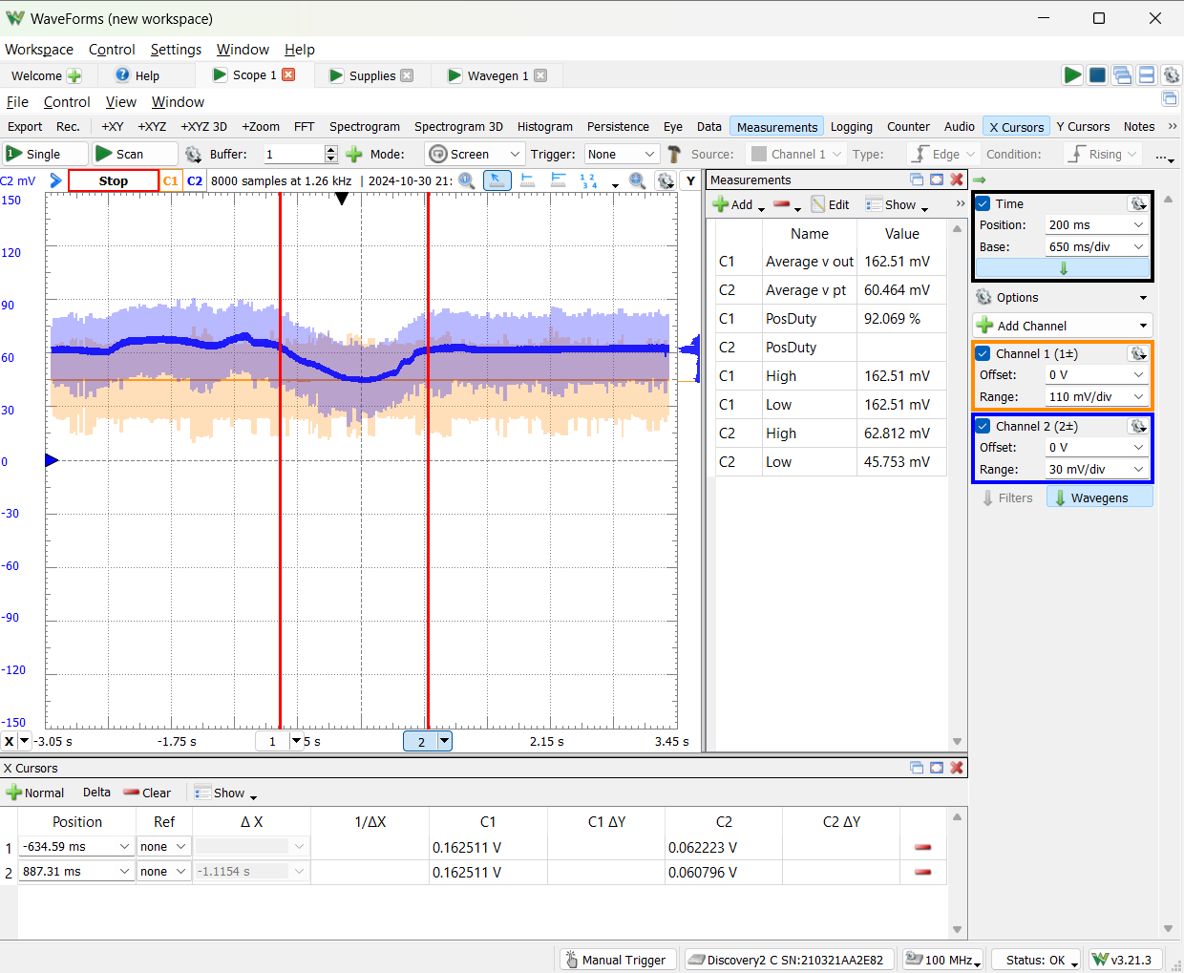

Begins crossing